Lesson: Kirchhoff’s Laws in Circuits

1. Introduction
When we analyze electrical circuits, Ohm’s Law (V = IR) is not always enough, especially for circuits with multiple loops or junctions.
To solve such circuits, we use Kirchhoff’s Laws:
- Kirchhoff’s Current Law (KCL) – about currents at a junction.
- Kirchhoff’s Voltage Law (KVL) – about voltages in a loop.

2. Kirchhoff’s Current Law (KCL)

Rule: At any junction, the total current entering = the total current leaving.

Formula: $\sum{I_{in}}=\sum{I_{out}}$

🔌 Analogy: Think of water pipes at a junction. The amount of water flowing in must equal the amount flowing out (no water disappears).

Example:
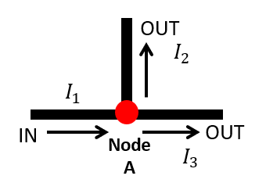
At Node A,
- Current entering: $I_{1}$
- Current leaving: $I_{2}$ and $I_{3}$

By KCL:
$\sum{I_{in}}=\sum{I_{out}}$
$I_{1}=I_{2}+I_{3}$

3. Kirchhoff’s Voltage Law (KVL)

Rule: The sum of voltages around any closed loop is zero.

Formula: $\sum{V^{'}s}=0$
$\sum{V_{drops}}=\sum{V_{rises}}$

🔋 Analogy: Walking around a circular path. If you start at ground level and walk up and down hills, when you come back to your starting point, your total elevation change is zero.

Sign Convention
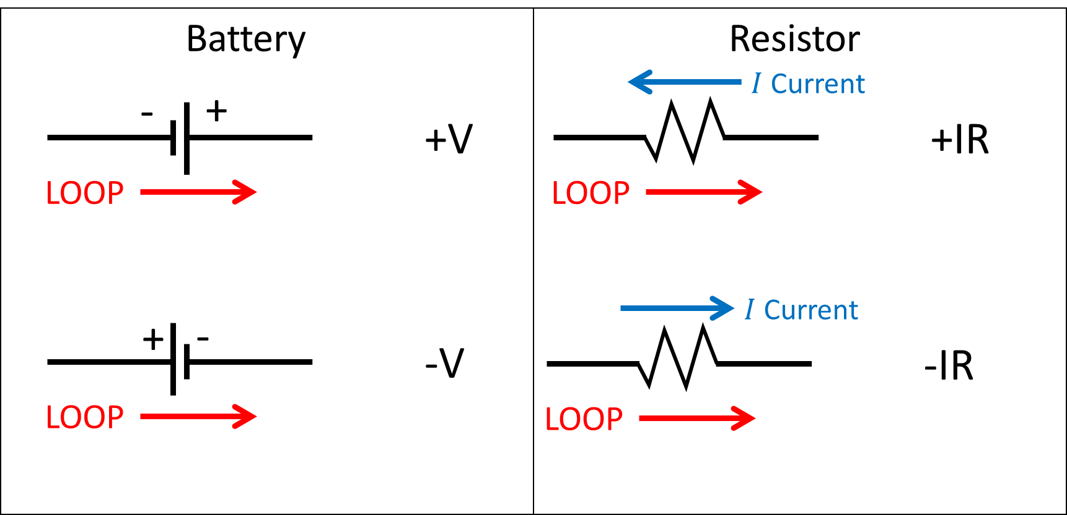

Example:
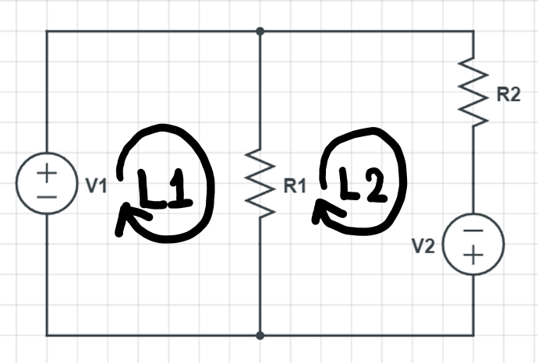
At Loop 1,
$\left({-V}_{1}\right)+\left(+I_{2}R_{1}\right)=0$
At Loop 2,
$\left(+V_{2}\right)+\left(+I_{2}R_{1}\right)+\left(-I_{3}R_{2}\right)=0$

- Solving the current along each path.
To solve for the current along each path using Kirchhoff’s Laws, first assign assumed directions for the branch currents, then apply KCL at the junctions to relate the currents and KVL around each loop to account for the voltage rises and drops; these laws give you a set of simultaneous equations, which can be solved algebraically or with tools like Matlab to find the unknown currents, and if a solution comes out negative, it simply means the true current flows opposite to the assumed direction.

How to use Matlab for Circuit Analysis
*Matlab or Octave
https://www.mathworks.com/products/matlab-online.html
https://octave-online.net/

